**Lab1: Analyze the relationship between the size of houses (measured in square**

**footage) and their selling prices in a particular neighborhood. You have collected**

**data on various houses in that neighborhood.Create a scatter plot using the**

**below data and share your conclusion/analysis.**

**Input:**

**square_footage = np.array([1200, 1400, 1600, 1800, 2000, 2200, 2400, 2600, 2800,**

**3000])**

**selling_prices = np.array([250, 290, 315, 380, 410, 450, 500, 525, 570, 610])**

**Code:**

**import numpy as np**

**import matplotlib.pyplot as plt**

**# Data**

**square_footage = np.array([1200, 1400, 1600, 1800, 2000, 2200, 2400, 2600, 2800, 3000])**

**selling_prices = np.array([250, 290, 315, 380, 410, 450, 500, 525, 570, 610])**

**# Create scatter plot**

**plt.scatter(square_footage, selling_prices, color='green')**

**plt.title('Housing Prices vs. Square Footage')**

**plt.xlabel('Square Footage (sq. ft.)')**

**plt.ylabel('Selling Price ($000s)')**

**# Display the plot**

**plt.grid(True)**

**plt.show()**

**Output:**

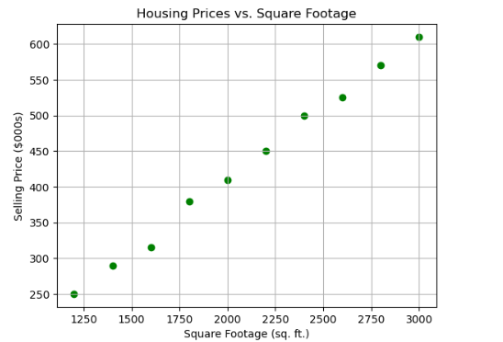

**Conclusion:**

1. **Positive Correlation: As the square footage of houses increases, the selling price also rises consistently. This suggests that larger homes are valued more highly.**
2. **Linear Trend: The data points form a pattern that closely resembles a linear relationship, indicating that square footage is a significant factor in determining housing prices.**
3. **Implication: Buyers seeking more space should expect to pay proportionally higher prices, and sellers can use this trend to estimate the value of homes based on their size.**

**Lab2: Create a pie chart to visualize the distribution of your monthly income by source. You have collected data on the various sources of your income, such as salary, freelance work, investments, and rental income. Share your conclusion/analysis.**

**Input: income_sources = ['Salary', 'Freelance', 'Investments', 'Rental', 'Other'] monthly_income = [5000, 1500, 1000, 600, 400]**

**Code:**

**import matplotlib.pyplot as plt**

**# Data**

**income_sources = ['Salary', 'Freelance', 'Investments', 'Rental', 'Other']**

**monthly_income = [5000, 1500, 1000, 600, 400]**

**# Create the pie chart**

**plt.pie(**

**monthly_income,**

**labels=income_sources,**

**autopct='%1.1f%%',**

**startangle=90,**

**colors=['lightcoral', 'lightskyblue', 'lightgreen', 'peachpuff', 'lavender']**

**)**

**plt.title('Distribution of Monthly Income by Source')**

**# Display the chart**

**plt.axis('equal') # Ensure the pie chart is circular**

**plt.show()**

**Output:**

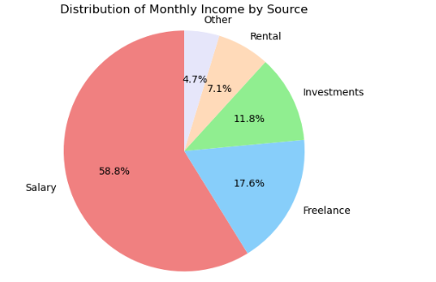

**Conclusion:  
The pie chart shows that most of the monthly income (58.8%) comes from a salary, making it the main source.**

* **Freelance work adds a significant 17.6%, while smaller amounts come from investments (11.8%), rental income (7.1%), and other sources (4.7%).**
* **This means the income is mostly steady from the salary, with some extra money coming from other sources, which helps make the overall income more balanced.**

**Lab3: Create a pie chart to illustrate the distribution of a company's revenue across its various business segments. You have collected data on the revenue generated by each segment, such as Product A, Product B, Services, and Licensing. Share your conclusion/analysis.**

**Input: segments = ['Product A', 'Product B', 'Services', 'Licensing'] revenue_percentages = [45, 25, 15, 15]**

**Code:**

**import matplotlib.pyplot as plt**

**# Data**

**segments = ['Product A', 'Product B', 'Services', 'Licensing']**

**revenue_percentages = [45, 25, 15, 15]**

**# Create the pie chart**

**plt.pie(**

**revenue_percentages,**

**labels=segments,**

**autopct='%1.1f%%',**

**startangle=90,**

**colors=['skyblue', 'lightgreen', 'gold', 'lightcoral']**

**)**

**plt.title('Distribution of Revenue Across Business Segments')**

**# Display the chart**

**plt.axis('equal') # Ensure the pie chart is circular**

**plt.show()**

**Output:**

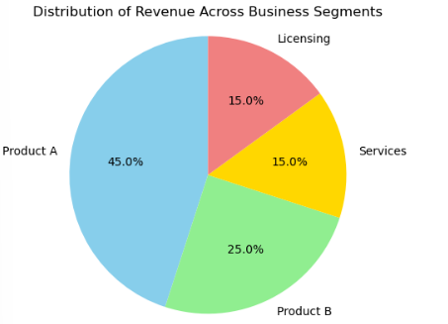

**Conclusion:**

* **The pie chart shows that most of the company's revenue (45%) comes from Product A, making it the main source of income.**
* **Product B adds 25%, while Services and Licensing each contribute 15%.**
* **This means the company gets most of its money from Product A but also earns from other areas, making its income more balanced.**

**Lab4: Suppose you're a sales manager for an e-commerce company, and you want to create a figure with subplots to compare the sales performance of different product categories over time. You have sales data for four product categories: Electronics, Clothing, Home & Garden, and Sports & Outdoors. Share your conclusion/analysis.**

**Input:**

**months = np.arange(1, 13) electronics_sales = np.array([25000, 28000, 31000, 27000, 30000, 32000, 35000, 36000, 38000, 39000, 41000, 42000])**

**clothing_sales = np.array([15000, 16000, 17000, 18000, 19000, 20000, 21000, 22000, 23000, 24000, 25000, 26000])**

**home_garden_sales = np.array([18000, 19000, 20000, 21000, 22000, 23000, 24000, 25000, 26000, 27000, 28000, 29000])**

**sports_outdoors_sales = np.array([12000, 13000, 14000, 15000, 16000, 17000, 18000, 19000, 20000, 21000, 22000, 23000])**

**Code:  
import numpy as np**

**import matplotlib.pyplot as plt**

**# Data**

**months = np.arange(1, 13)**

**electronics_sales = np.array([25000, 28000, 31000, 27000, 30000, 32000, 35000, 36000, 38000, 39000, 41000, 42000])**

**clothing_sales = np.array([15000, 16000, 17000, 18000, 19000, 20000, 21000, 22000, 23000, 24000, 25000, 26000])**

**home_garden_sales = np.array([18000, 19000, 20000, 21000, 22000, 23000, 24000, 25000, 26000, 27000, 28000, 29000])**

**sports_outdoors_sales = np.array([12000, 13000, 14000, 15000, 16000, 17000, 18000, 19000, 20000, 21000, 22000, 23000])**

**# Create subplots**

**fig, axs = plt.subplots(2, 2, figsize=(10, 8))**

**fig.suptitle('Monthly Sales Performance by Product Category')**

**# Plot Electronics**

**axs[0, 0].plot(months, electronics_sales, marker='o', color='blue')**

**axs[0, 0].set_title('Electronics')**

**axs[0, 0].set_xlabel('Months')**

**axs[0, 0].set_ylabel('Sales ($)')**

**axs[0, 0].grid(True)**

**# Plot Clothing**

**axs[0, 1].plot(months, clothing_sales, marker='o', color='red')**

**axs[0, 1].set_title('Clothing')**

**axs[0, 1].set_xlabel('Months')**

**axs[0, 1].set_ylabel('Sales ($)')**

**axs[0, 1].grid(True)**

**# Plot Home & Garden**

**axs[1, 0].plot(months, home_garden_sales, marker='o', color='green')**

**axs[1, 0].set_title('Home & Garden')**

**axs[1, 0].set_xlabel('Months')**

**axs[1, 0].set_ylabel('Sales ($)')**

**axs[1, 0].grid(True)**

**# Plot Sports & Outdoors**

**axs[1, 1].plot(months, sports_outdoors_sales, marker='o', color='orange')**

**axs[1, 1].set_title('Sports & Outdoors')**

**axs[1, 1].set_xlabel('Months')**

**axs[1, 1].set_ylabel('Sales ($)')**

**axs[1, 1].grid(True)**

**# Adjust layout**

**plt.tight_layout(rect=[0, 0, 1, 0.96])**

**plt.show()**

**Output:**

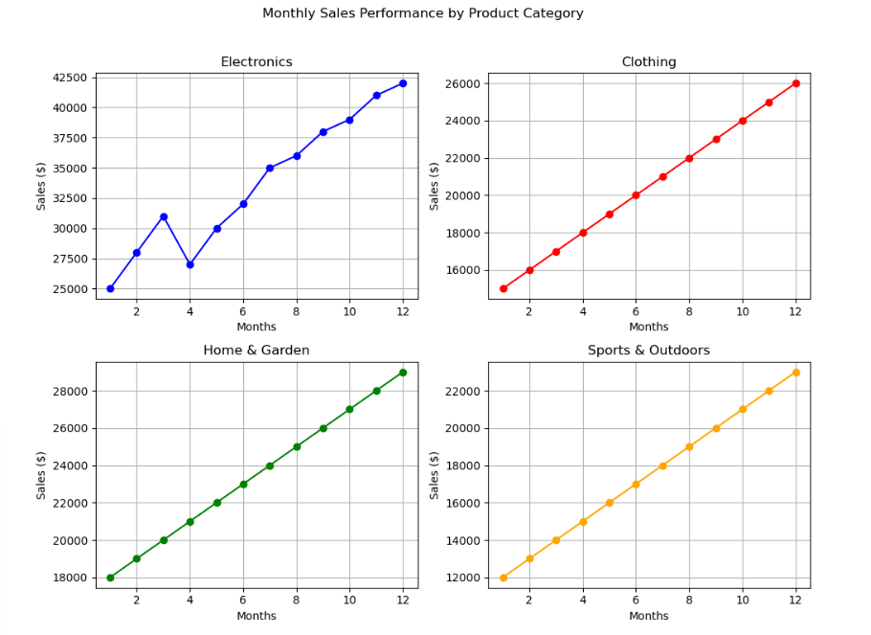

**Conclusion:**

* **Electronics have the highest sales, especially toward the end of the year.**
* **Clothing and Home & Garden both show steady growth over time.**
* **Sports & Outdoors has the lowest sales but still grows consistently.**
* **Overall, electronics are the strongest performer, while the other categories contribute steadily.**